*Florida International University*

*School of Computing and Information Sciences*

CIS 4911 - Senior Capstone Project

Software Engineering Focus

Feature Document

User Story # 1076

**Team Member:**

Daniel Lopez

**Product Owner(s)**:

Mohsen Taheri

**Mentor(s)**:

Mohsen Taheri

**Instructor**:

Mohsen Taheri

**User Story** Modify and update forget password.

**Description**

As a VIP user, I would like to recover my account so that I can log in if I forget me password.

**Acceptance Criteria**

1. Send an email to confirm if user forgot password.
2. Click on the link to create a new password.

**Use Case**

1. Participating Actors: User  
     
   Entry Condition: Forgot Password  
   Events Flow:
2. Click forgot password.
3. Enter email.
4. Receive email.
5. Click email link.
6. Enter new password and confirm new password.

**Use Case Diagram**

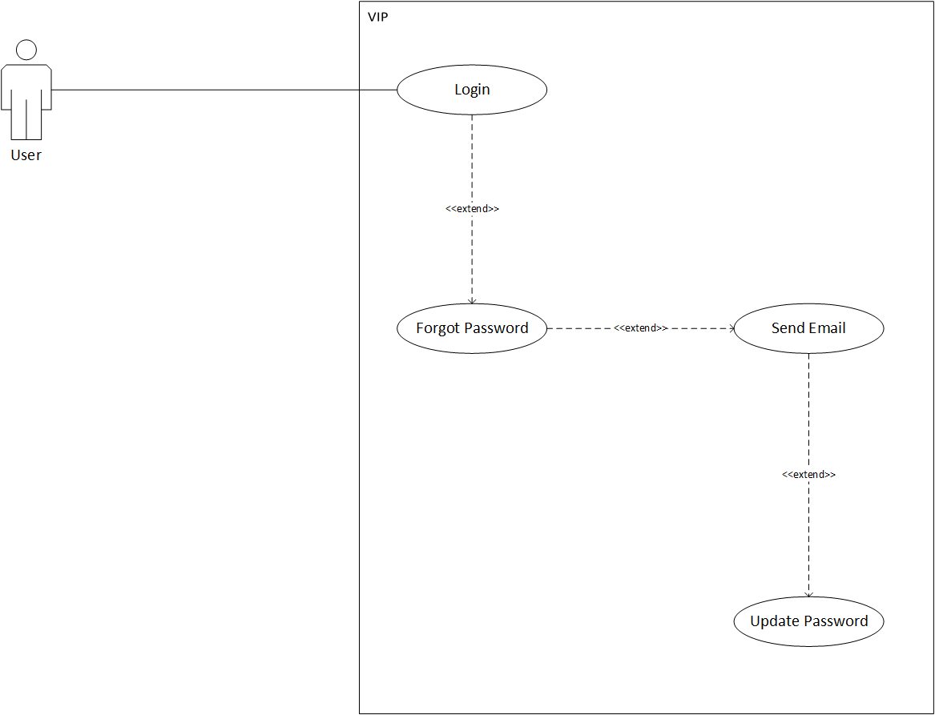

**Sequence Diagram**

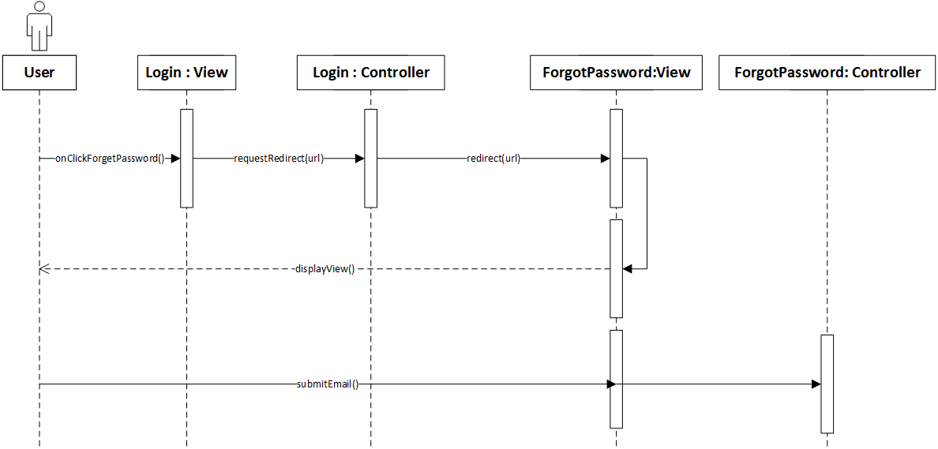

**Class Diagram**

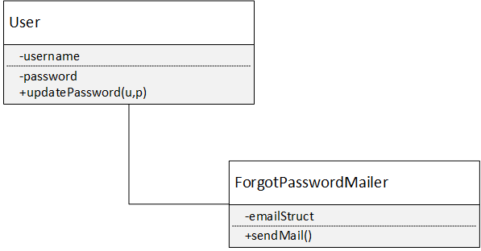

**Unit Test & Integration Test**

**Test Case 1 Sunny Day (PASS)**

* **Purpose**

To test that forget password works.

* **Precondition**

Forgotten password.

* **Input**

Email bound to account and and new password.

* **Expected Result**

Email recieved, and link works, and able to change password.

* **Actual Result**

As Expected Result.

**Test Case 2 Rainy Day (FAIL)**

* **Purpose**

To test that forget password does not work.

* **Precondition**

Forgotten password.

* **Input**

Email bound to account and and new password.

* **Expected Result**

Email received, and link works, and not able to change password.

* **Actual Result**

Email received, and link works, and able to change password.

**Visual User Guide**

